**SRM INSTITUE OF SCIENCE AND TECHNOLOGY**

**TIRUCHIRAPPALLI CAMPUS, TIRUCHIRAPPALLI – 621105.**

**FEEDBACK REPORT**

**B.TECH. COMPUTER SCIENCE AND ENGINEERING – 2022 – 2023**

**SEMESTER : I YEAR : I / CSE A**

**TERM : MID SEM MONTH: NOVEMBER**

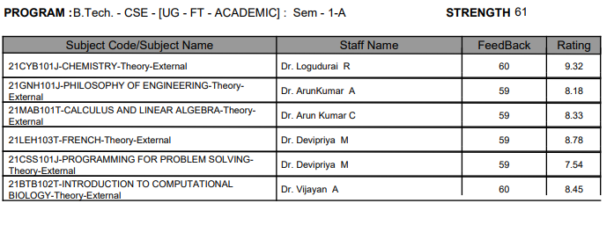

**SEMESTER : I YEAR : I / CSE B**

**TERM : MID SEM MONTH: NOVEMBER**

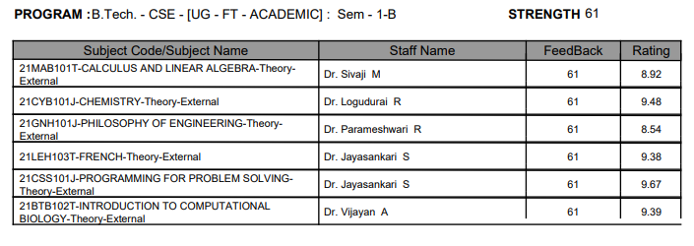

**SEMESTER : I YEAR : I / CSE C**

**TERM : MID SEM MONTH: NOVEMBER**

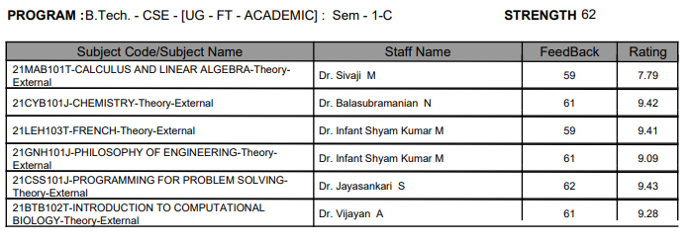

**B.TECH. COMPUTER SCIENCE AND ENGINEERING WITH AIML**

**SEMESTER : I YEAR : I / AIML A**

**TERM : MID SEM MONTH: NOVEMBER**

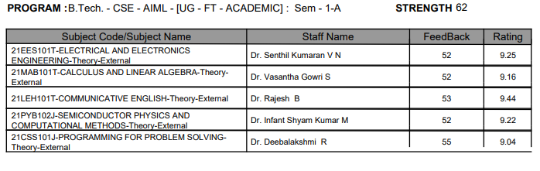

**SEMESTER : I YEAR : I / AIML B**

**TERM : MID SEM MONTH: NOVEMBER**

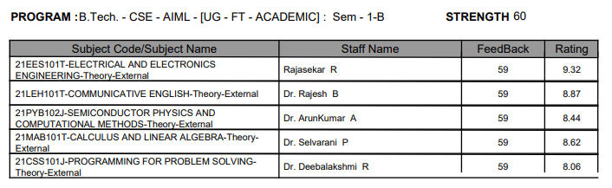

**B.TECH. COMPUTER SCIENCE AND ENGINEERING WITH CYBER SECURITY**

**SEMESTER : I YEAR : I / CS**

**TERM : MID SEM MONTH: NOVEMBER**

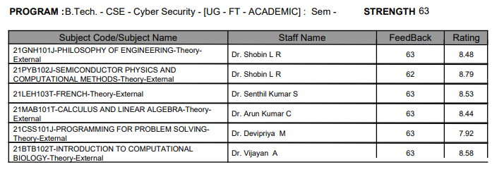

**B.TECH. ELECTRONICS AND COMMUNICATIN ENGINEERING**

**SEMESTER : I YEAR : I / ECE**

**TERM : MID SEM MONTH: NOVEMBER**

